PROJECT REPORT ON

**Cyber Hunt**

**Submitted by:**

1. Sahasra Reddy. M (CH.EN.U4CYS21037)
2. Charishma. L (CH.EN.U4CYS21010)
3. Chinni Krishna Kowsik. P (CH.EN.U4CYS21011)
4. Abhishek Sharma (CH.EN.U4CYS21001)
5. Aditya Vatsa (CH.EN.U4CYS21003)

Under the Guidance of:

Dr. Chandralekha

Department of Computer Science

Mr. M. Durga Rao

Department of Computer Science

**December 2022**



Department of Computer Science & Engineering

(Cyber Security)

Amrita Vishwa Vidyapeetham

Chennai Campus, Vengal, 601103

Certificate

This is to certify that Sahasra Reddy. M (CH.EN.U4CYS21037), Charishma. L (CH.EN.U4CYS21010) ,Chinni Krishna Kowsik. P (CH.EN.U4CYS21011), Abhishek Sharma (CH.EN.U4CYS21001) and Aditya Vatsa (CH.EN.U4CYS21003) have successfully completed the project titles “Cyber Hunt ” under the supervision and guidance in the fulfillment of requirements of Third Semester, Bachelor of Technology (Computer Science & Engineering Cyber Security) of Amrita School of Engineering, Chennai.

_______________________ _______________________

Asst. Prof. Dr. Chandralekha Department of Computer Science & Engineering

Mr. M.S.P. Durga Rao Department of Computer Science & Engineering

ACKNOWLEDGMENT

We deem it a pleasure to acknowledge our sense of gratitude to our project guides Asst. Prof. Dr. Chandralekha and Mr. M.S.P. Durga Rao under whom we have carried out the project work.

We wish to reciprocate in the full measure the kindness shown by Asst. Prof. Dr. Chandralekha and Mr. M.S.P. Durga Rao

who inspired us with their valuable suggestions in successfully completing the project work.

We shall remain grateful to Asst. Prof. Dr. Chandralekha and Mr. M.S.P. Durga Rao for providing us a strong academic atmosphere by enforcing strict discipline to do the project work with utmost concentration and discipline.

Finally we must say that no height is ever achieved without some sacrifices made it some end and it is here where we go our special to our parents and our friends for showing their generous love and care throughout the entire period of time.

______________________

Sahasra Reddy. M

______________________

Charishma. L

______________________ Chinni Krishna Kowsik. P

______________________

Abhishek Sharma

______________________

Aditya Vatsa

ABSTRACT

MySQL is one of the most popular database management systems (DBMSs) on the market today. It ranked second only to the Oracle DBMS in this year’s DB-Engines Ranking. As most software applications need to interact with data in some form, programming languages like Python provide tools for storing and accessing these data sources.

In the fast-growing field of cyber security and even more rapidly growing sector of game development the future is hard to predict.

we are working with this game as our capstone project and as part of our degree we choose this of work for doing better with development, graphics, scripting, adopting new technology, animation.

In a game project, the product is game but the main point is a game is much more than just its code. It has to provide content to become enjoyable and Knowledgeable. Just like a web server, without content the server is useless and the quality cannot be measured.

CONTENTS

|  |  |  |
| --- | --- | --- |
| No. | Topics | Page |
| 1 | Introduction | 5 |
| 2 | Software requirements and specifications | 5 |
| 3 | Project plan | 8 |
| 4 | Game overview | 9 |
| 5 | Target audience | 9 |
| 6 | Game description | 9 |
| 7 | Er and UML diagram | 11 |
| 8 | Why game as a project | 12 |
| 9 | Future development | 12 |
| 10 | Conclusion | 13 |

Introduction

This report describes the process involved in making this cyber hunt game. This game is for both PC and Android devices.

This chapter discusses the game overview including the synopsis, target audience, description then focuses on the game design

Software Requirements And Specifications

# Python

Python is dynamically-typed and garbage-collected programming language.

It supports multiple programming paradigms, including structured (particularly procedural), object-oriented and functional programming.

Rather than building all of its functionality into its core, Python was designed to be highly extensible via modules.

This compact modularity has made it particularly popular as a means of adding programmable interfaces to existing applications.

# MySQL

MySQL is a widely used relational database management system (RDBMS).

MySQL is free and open-source.

MySQL is ideal for both small and large applications.

Flask

Flask is a micro web framework written in Python. It is classified as a microframework because it does not require particular tools or libraries. It has no database abstraction layer, form validation, or any other components where pre-existing third-party libraries provide common functions.

Project Plan

In Python you need to install a Python MySQL connector to interact with a MySQL database. pip installs the connector as a third-party module in the currently active virtual environment. It’s recommended that you set up an isolated virtual environment for the project along with all the dependencies.

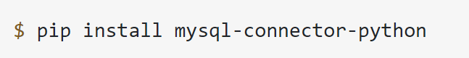

To interact with a database, you must first establish a connection with the server. The general workflow of a Python program that interacts with a MySQL-based database is as follows:

* Connect to the MySQL server.
* Create a new database.
* Connect to the newly created or an existing database.
* Execute a SQL query and fetch results.
* Inform the database if any changes are made to a table.
* Close the connection to the MySQL server.

The first step in interacting with a MySQL server is to establish a connection. To do this, you need connect() from the mysql.connector module. This function takes in parameters like host, user, and password and returns a MySQLConnection object. You can receive these credentials as input from the user and pass them to connect():

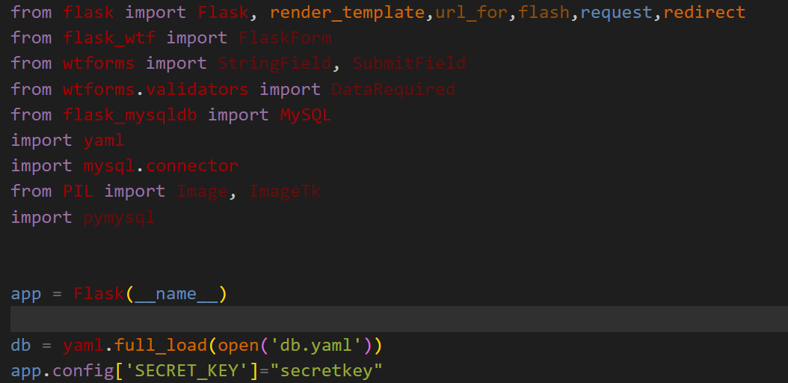

GAme overview

The primary objective of this game is to gain knowledge about cyber security by getting the flag, player can only achieve that if he clears the challenge that he has been assigned in. Throughout the game, there are various challenges, obstacles and quiz.

Each area of the game has different set of challenges, player can only go further if he clears the current challenge. Cyber hunt game dreams to teach everyone about cyber security in a fun and interactive way.

Target audience

Hunting Game is extremely popular especially in mobile device and pc. The Hunt game called Soul hunt has over 1000000+ installs on google play.

This shows that a large base of players are actively interested in this genre and gives me a good opportunity to tap into that market by following the traditions that have already set for this genre. But we are mainly targeting to casual people aged from 10-35.

Game Description

This game is a single player game. The game is inhabited by various challenges and quiz that player have to solve to win.

If the player successfully completes the challenge, then the player gains experience points and if the experience points are max as the current level, then the player gets promoted and the process goes on until he has max points.

In this game we have 4 challenges for the player to play and besides the challenges we have 2 quizzes also

Game – 1 :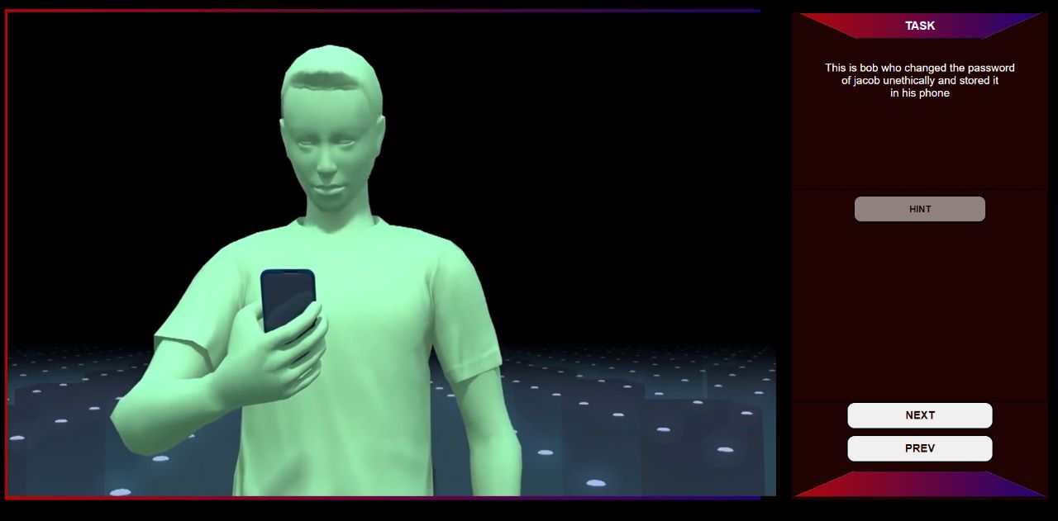

Game – 2 :

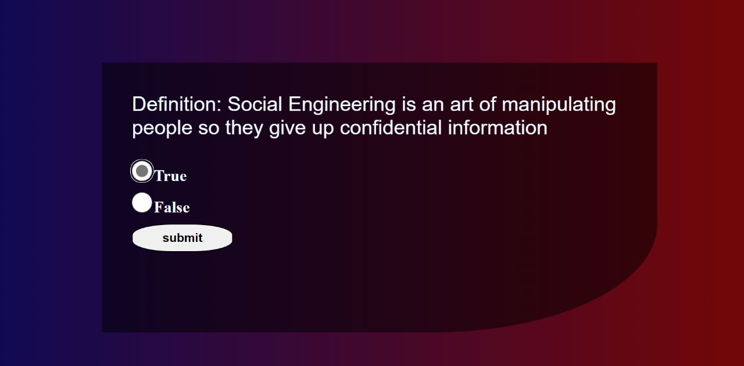

**ER diagram :**

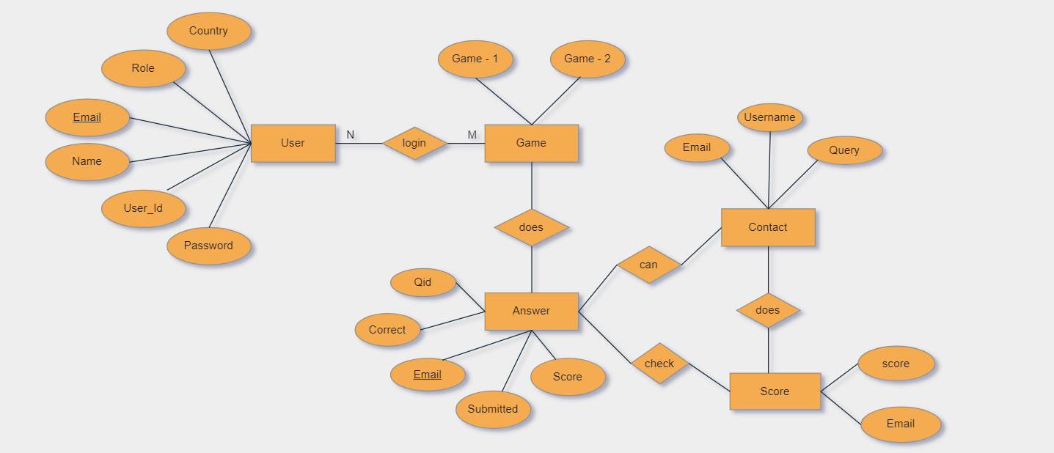

**UML Class diagram :**

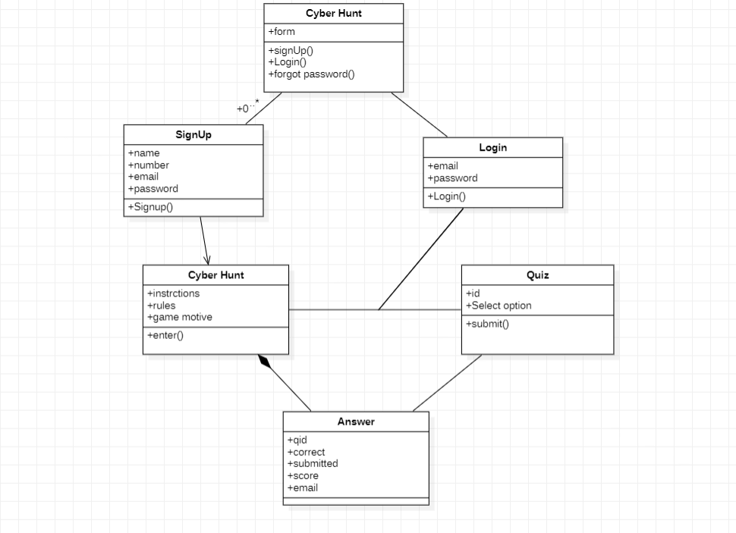

Why GAME AS A PROJECT ?

Games are not just any computer application which are made to benefit user's daily life but also game are made for user's entertainment purpose, so more than anything we need to pay attention to what the user wants from the game, how to make it more entertaining, just making any game will not do, that is why it's more challenging because we always have to carefully consider if we are developing it correctly to entertain users.

we also have to invest a lot of time on the proper game designing to make it visually accepted. And to add that game requires a lot of scripts.

The Script are like pieces of puzzle which need to put all of them together to make it work.

Thus we think game is a perfect project to improve ourselves as CYS students.

Future development

In future we are planning to add more challenges and making game worldwide so that everyone can learn about cyber security and ethical hacking.

Also, we are optimizing it so that it will work in every device or system.

Conclusion

It was a wonderful learning experience for me while working on this project. This project took me through the various phases of project development and gave me real insight into the world of software engineering. The joy of working and the thrill involved while tackling the various problems and challenges gave me a feel of the developers’ industry.

It was due to this project I came to know how professional software is designed.

**Code link :**

<https://github.com/kowsik11/DBMS_and_APL_Capstone/tree/main/dbms_project>

**Presentation Link :**

<https://github.com/kowsik11/DBMS_and_APL_Capstone/blob/main/dbmsApl_PPT.pdf>

After opening the link, click on the download.

**Report link :** <https://github.com/kowsik11/DBMS_and_APL_Capstone/blob/main/DBMS%20AND%20APL%20capstone%20project.docx>